

Lovely Professional University
Jalandhar, Punjab, India.

Delivered by: | Received by:
Names of the student:  ABHISHEK SINGH  Reg. No.:  12221592  Roll No.:  RK22UN65  Signature: | Name of the faculty:  SHUBHAM SHARMA  UID:  64339  Signature:

Acknowledgement
I would like to acknowledge my mentor, Mr. Shubham Sharma, for their invaluable guidance and support during the development of this Java Music Player. This application was created to manage music playlists and queues and provides a user-friendly interface for users to interact with their music collection.
I, Abhishek Singh, as the developer of this application, am grateful for the mentorship and assistance provided by Mr. Shubham Sharma throughout the project.
Please note that this is a basic implementation of a music player and can be further improved and extended with more advanced features.

- Abhishek Singh
Reg. No. 12221592

Table Of Contents:

- Introduction
- Objectives And Scope Of The Project
- Application Tools
- Methodology/Flowchart or Algorithm Implementation
- Screenshots Of The Execution
- Summary
- Bibliography
- Annexure

Introduction:
The Music Player application is a Java program designed to mimic the behavior of a typical music player. It offers a range of features for managing a music playlist, searching for songs, creating a playback queue, editing the queue (adding and removing songs), changing the play mode, and controlling song playback
Abstract:
This Java program presents a simple command-line-based music player application. The program allows users to manage a playlist, search for songs, create and edit queues, change play modes, and play music. It employs object-oriented principles to encapsulate song-related information and utilizes various algorithms for playlist management and song playback.
.

Application Tools
In the development of the Java Mini Music Player, a variety of software tools and applications were employed to facilitate the creation, testing, and execution of the application. The following tools were essential for the development process:

1. IntelliJ IDEA
- IntelliJ IDEA, a powerful integrated development environment (IDE), was the primary tool used for developing the Java Mini Music Player. It provided an intuitive and feature-rich environment for code writing, debugging, and project management. IntelliJ IDEA's code analysis, debugging capabilities, and code navigation significantly expedited the development process.

2. Visual Studio Code (VS Code)
- Visual Studio Code, a versatile and lightweight code editor, complemented the development process. While primarily known for web development, VS Code's extensibility and broad language support made it valuable for code reviews, documentation, and additional development tasks.

3. Java Programming Language
- The Java programming language served as the foundational language for the Java Mini Music Player. Java's platform independence and extensive standard library made it an ideal choice for creating a versatile music management application. The code was organized into classes, utilized data structures, and employed control flow to handle music-related information.

4. Text Editor
- A text editor was used to create and organize data, particularly for initial playlist entries. While various text editors can fulfill this role, a basic text editor was employed to format song information before integration into the Java Mini Music Player.

5. Git and GitHub
- Version control was maintained using Git, and the code repository was hosted on GitHub. This allowed for collaboration, code versioning, and project backup. It also facilitated the management of multiple code branches, making it easier to experiment with new features and updates.

These tools and applications played a crucial role in the successful development of the Java Mini Music Player, offering the necessary infrastructure for code creation, data management, and overall project execution.

Objectives And Scope Of The Project

Objectives:
1. Music Management: The primary objective of this project is to create a Java application for managing music playlists, queues, and playback.
2. User Interaction: Enable users to interact with the application through a menu-driven command-line interface (CLI) to perform actions such as adding songs, creating queues, changing play modes, and playing music.
3. Error Handling: Implement error handling to provide user-friendly messages in cases of invalid input or unexpected errors.

Scope:
1. Music Playlist Management: The project's scope includes the creation, display, and modification of a music playlist. Songs are stored in a playlist using a list data structure.
2. Queue Management: The application allows users to create and modify queues of songs based on search criteria or by adding and removing individual songs.
3. Play Modes: Users can change the play mode, including options for repeating the same song, repeating all songs, and shuffling the playlist.
4. User Interaction: The application provides a user-friendly CLI for interactions, allowing users to add songs, display the playlist, search for songs, edit queues, change play modes, play the next song, and check the currently playing song.
5. Error Handling: The project addresses potential errors, such as invalid input or accessing songs that don't exist in the queue, by providing informative error messages.
6. Limited Data Transformation: The project focuses on managing and playing music and does not involve complex data analysis or transformations.
7. Offline Operation: The application operates offline, as it doesn't rely on external data sources or internet connectivity for music playback and management.
8. Single-User Application: This application is designed for single-user interaction and is intended for personal music management.
Code Overview:
1. Song Class:
- Represents a song and stores its attributes, including title, artist, and duration.
- The `toString` method is used to display song details in a user-friendly format.
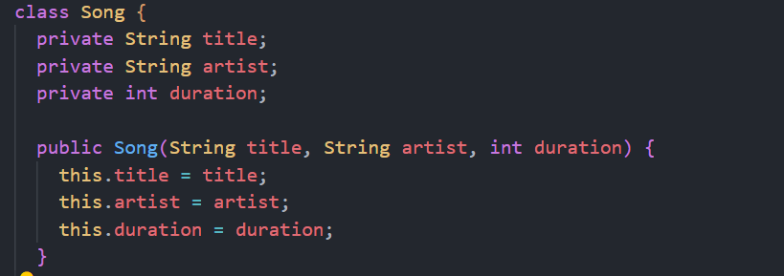

2. Musicplayer Class:
The central class responsible for handling the core functionality of the music player.
Maintains two queues: `listofsongs` (the main playlist) and `queue` (the playback queue).
Keeps track of the index of the currently playing song (`SongIndex`) and the current play mode (`playMode`).
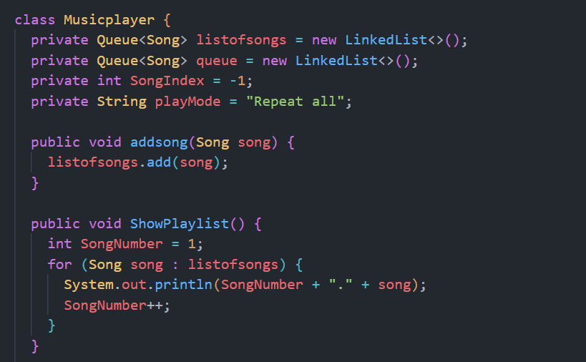
3. Methods in Musicplayer Class:
- `addsong(Song song)`: Allows users to add songs to the main playlist (`listofsongs`).
- `ShowPlaylist()`: Displays the complete playlist to the user.
- `NowPlaying()`: Informs the user about the song that is currently playing.
- `SearchSongs(String keyword)`: Searches the playlist for songs that match a given keyword.
- `QueueOfSong(String keyword)`: Creates a playback queue based on a user-specified keyword.
- `QueueEdit(String action, String value)`: Enables users to modify the playback queue by adding or removing songs.
- `ChangeMode(String mode)`: Allows users to change the play mode to "Repeat One," "Repeat All Songs," or "Shuffle."
- `NextSong()`: Implements the logic for playing the next song based on the selected play mode.
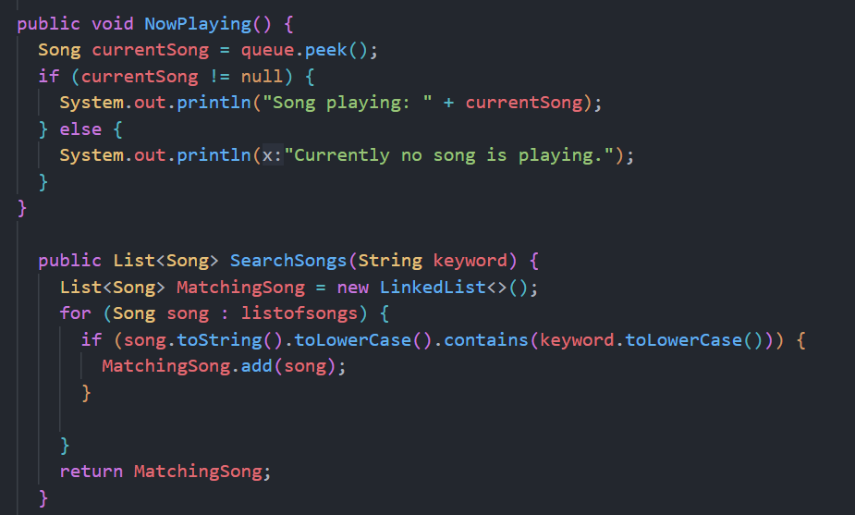
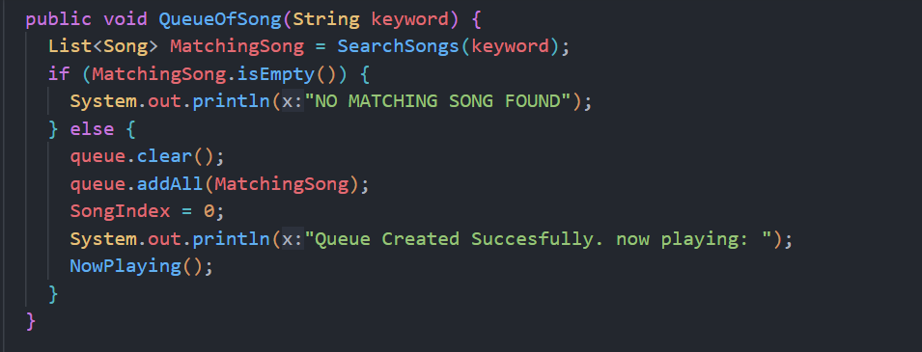
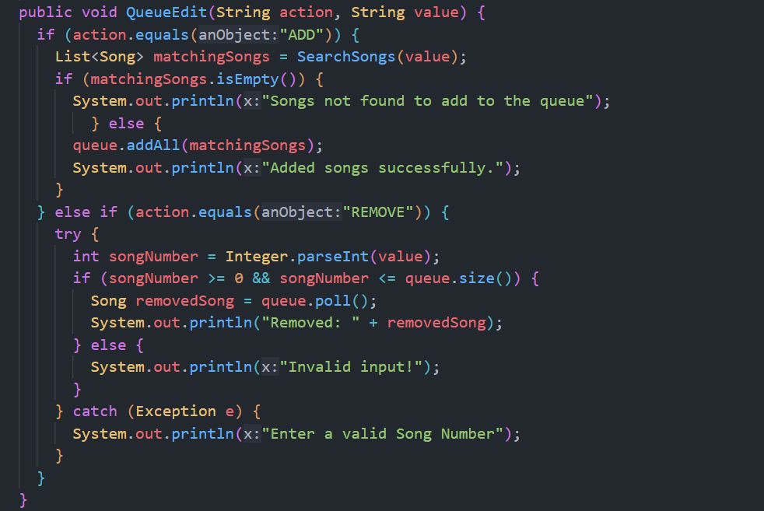
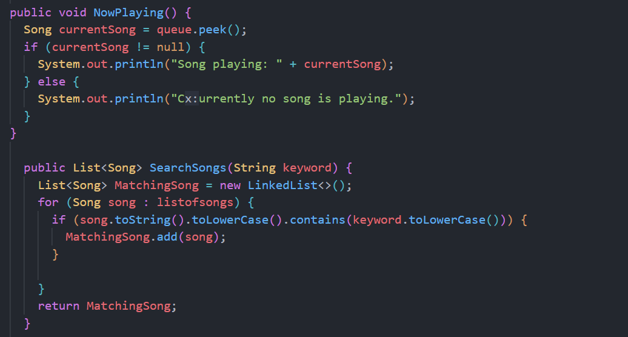
4. MiniMusicPlayer Class:
- Contains the `main` method, which is the entry point of the program.
- Provides users with a text-based menu for interacting with the music player.
- Offers various actions such as adding songs, displaying the playlist, searching for songs, editing the queue, changing the play mode, playing the next song, and checking the currently playing song.
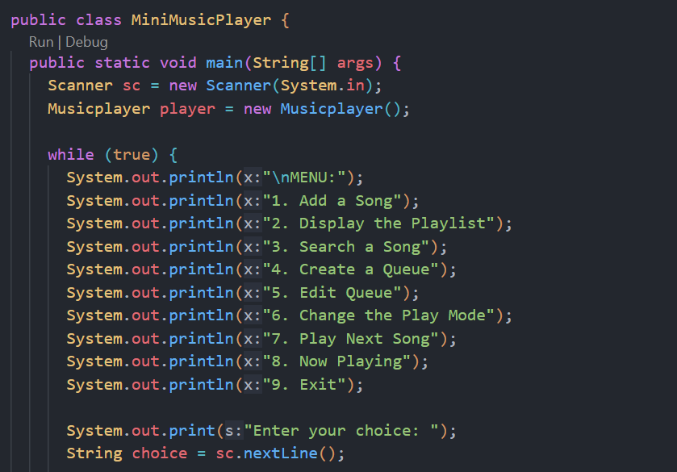
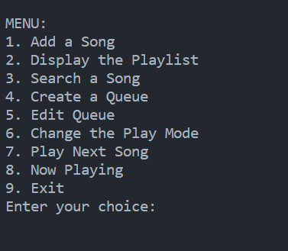
Key Features:

Playlist Management: Users can create, view, and maintain a playlist of songs using the `listofsongs` queue.
Play Modes:The application supports three play modes:
1. "Repeat the same Song" - Replays the current song.
2. "Repeat All Songs" - Plays songs in the playlist in a loop.
3. "Shuffle the playlist" - Shuffles the songs in the playlist and plays them randomly.

Search Functionality: Users can search for songs in the playlist by entering keywords, and the application returns a list of matching songs.
Playback Queue: Users can create a playback queue by specifying a keyword. The `queue` is used for playing songs.
Queue Editing: The application allows users to add or remove songs from the playback queue.
Real-time Feedback:Users receive real-time information about the currently playing song.

Suggestions for Improvement:
Error Handling: Enhance error handling to gracefully manage unexpected user inputs and exceptions.
User Interface: Consider developing a graphical user interface (GUI) to offer a more user-friendly experience.
Additional Features:Explore adding features like saving and loading playlists, creating custom playlists, and organizing songs into albums or playlists.
Conclusion:
The Music Player application demonstrates the fundamental principles of Java programming, including object-oriented design, the use of collections (queues), and user input handling. While it provides a basic set of features, there is significant potential for further development and enhancement, transforming it into a feature-rich and user-friendly music player application.

